EXERCISE 1:
IMPLEMENTING SINGLETON PATTERN

class Logger {
private static Logger instance;

private Logger() {
System.out.println("Logger instance created.");
}

public static Logger getInstance() {
if (instance == null) {
instance = new Logger();
}
return instance;
}

public void log(String message) {
System.out.println("Log: " + message);
} }

public class LoggerTest {
public static void main(String[] args) {
Logger logger1 = Logger.getInstance();
logger1.log("First log message.");

Logger logger2 = Logger.getInstance();
logger2.log("Second log message.");

if (logger1 == logger2) {
System.out.println("Both logger1 and logger2 are the same instance.");
} else {
System.out.println("Different instances created! Singleton failed.");
}
}
}

USING JDoodle COMPILER

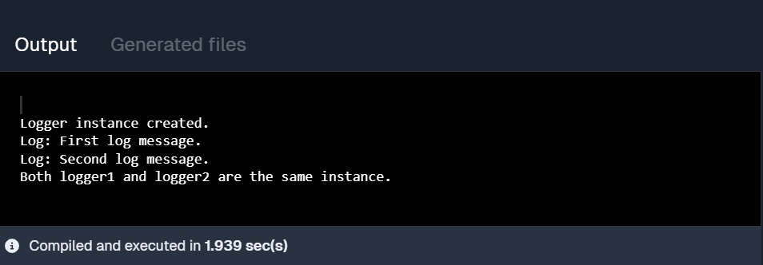

EXERCISE 2:
IMPLEMENTING THE FACTORY METHOD PATTERN
// Document interface
interface Document {
void open();
}
// Concrete Document classes
class WordDocument implements Document {
public void open() {
System.out.println("Opening a Word document.");
}
}
class PdfDocument implements Document {
public void open() {
System.out.println("Opening a PDF document.");
}
}

class ExcelDocument implements Document {
public void open() {
System.out.println("Opening an Excel document.");
}
}

// Abstract Factory
abstract class DocumentFactory {
public abstract Document createDocument();
}
// Concrete Factories
class WordFactory extends DocumentFactory {
public Document createDocument() {
return new WordDocument();
}
}

class PdfFactory extends DocumentFactory {
public Document createDocument() {
return new PdfDocument();
}
}

class ExcelFactory extends DocumentFactory {
public Document createDocument() {
return new ExcelDocument();
}
}

// Main test class
public class Main {
public static void main(String[] args) {
DocumentFactory wordFactory = new WordFactory();
Document wordDoc = wordFactory.createDocument();
wordDoc.open();

DocumentFactory pdfFactory = new PdfFactory();
Document pdfDoc = pdfFactory.createDocument();
pdfDoc.open();

DocumentFactory excelFactory = new ExcelFactory();
Document excelDoc = excelFactory.createDocument();
excelDoc.open();
}
}

USING JDoodle COMPILER

